Large Turnout for University Programs’ Semiannual Book Fair
By: Joanna House
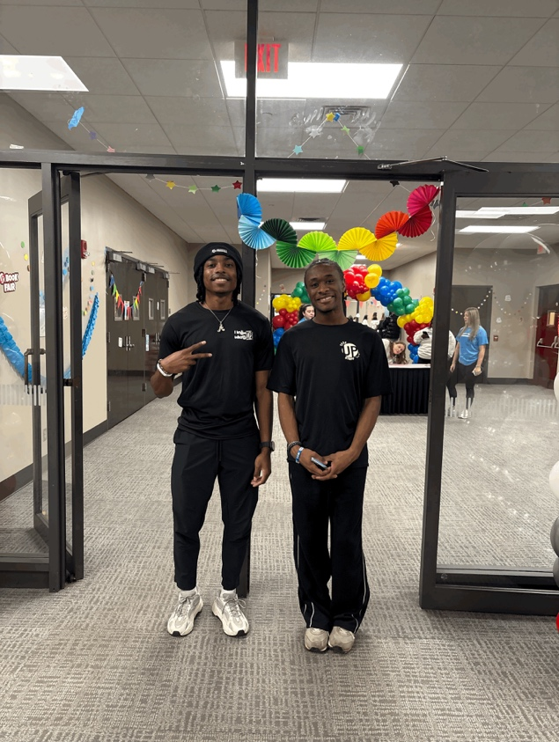
TUSCALOOSA, Ala. – University Programs hosted the on-campus Book Fair, offering books, crafts, and entertainment in the Student Center Ballroom on Jan. 22, which allowed students to connect with the university and each other. Several hundred students came to participate in the Book Fair. Mina Webster, a fourth-year University of Alabama student, attended the event with several of her friends. She said, “I heard that the books [last year] were amazing and that they sold out really fast.”
University Programs staff stood at the door to welcome students.
Welcome Back Weeks are hosted by UP and are a series of events in the first month of the spring semester. This event’s primary purpose is to build community for students and allow them to get the best experience out of their time at UA. This is the third time that this event has been held as a part of Welcome Weeks and Welcome Back Weeks. University Programs staff member Eddie Coats Jr. said the goal of bringing the event back is to reach as many students as possible and to have a fun time.
Along with the other crafts and snacks, UP also invited the Tuscaloosa Public Library to come to the event. TPL had representatives available to help UA students sign up for a library card that grants them access to the resources available in the library. Madison Love, the Tuscaloosa Public Library outreach assistant, said, “The more outreach that we can do and the more people that can benefit from our services the better our services are.”
Student engagement is a top priority of UP. Having large events such as this one as well as a mixture of smaller events allows them to bring students together and connect them with all UA has to offer.

